**USA Trade Analysis**

**Objective**:

We are hearing the terms ‘trade war’, ‘trade deficit’, ‘tariffs’, etc. more frequently these days. The purpose of this project to understand the international trade relations of USA and it’s import export patterns. This gave us an insight on USA’s trade partners and the common products imported and exported to and from USA.

**Data Sets:**

1. Trade dataset
2. Product codes dataset

**Data Cleaning:**

Done in python and attached the jupyter notebook along with.

**Data Visualization:**

1. We plotted the below chart to

* Analyze the trend of overall imports and exports
* Analyze the trade deficit
* Forecast the imports and exports for 2018

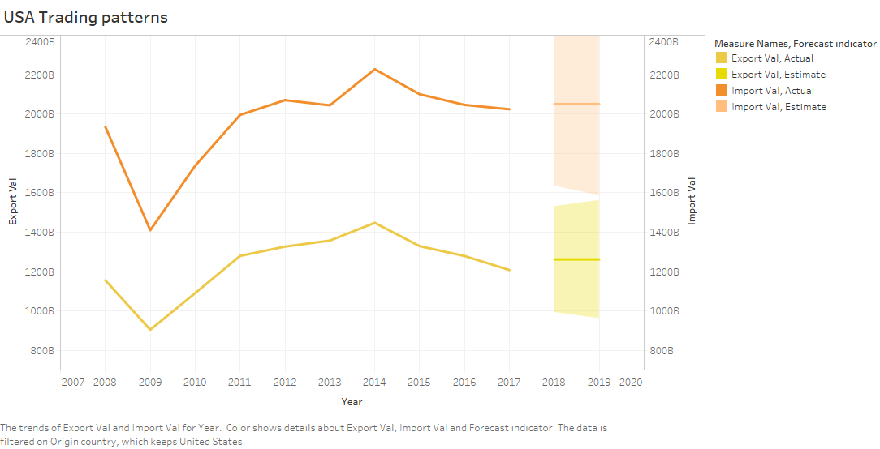

1. We have plotted the below graphs to see the product categories and sub categories that are most commonly exported and imported in the last 4 years (from 2014 to 2017)

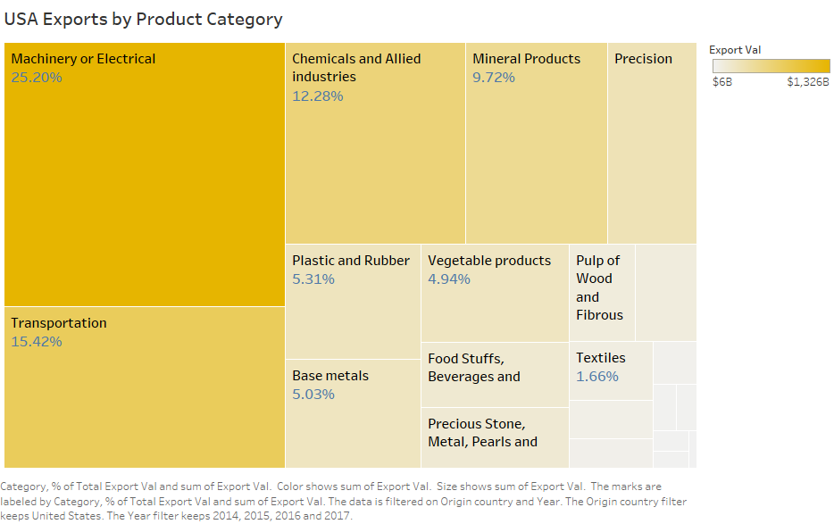

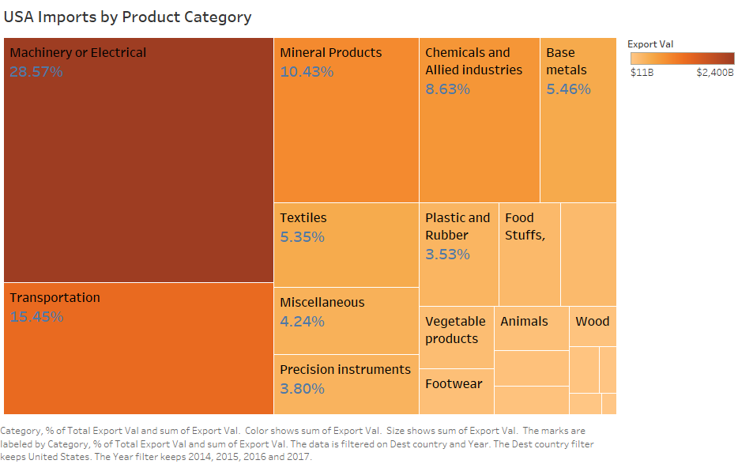

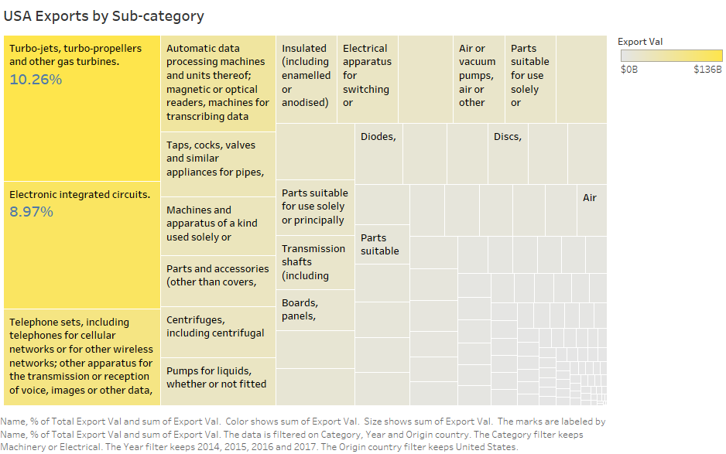

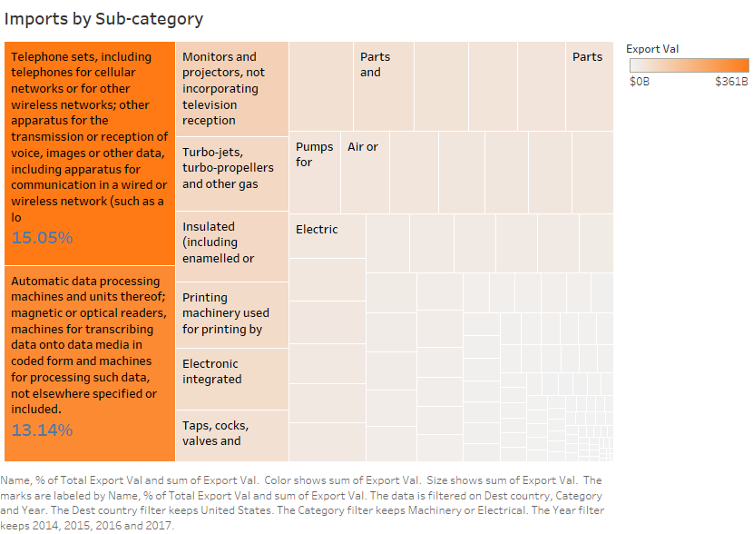

1. We have the below graph to study the trend of the most exported categories

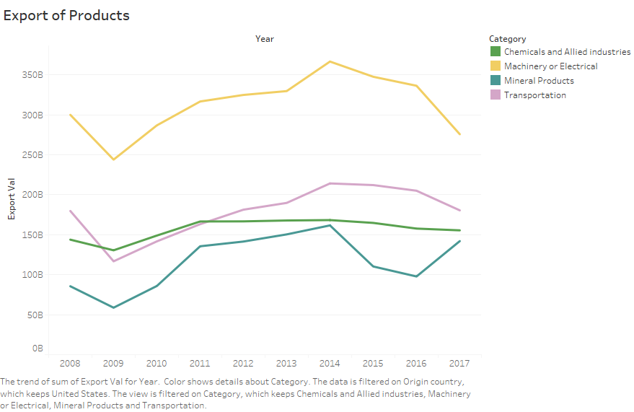

1. The below graph shows the trend of few imported categories. It has been observed that the imports of mineral products have decreased due to advent of new technologies to drill ores and oils. Also, it is seen that the imports of vegetable products, animal products and food stuff have been stable throughout.

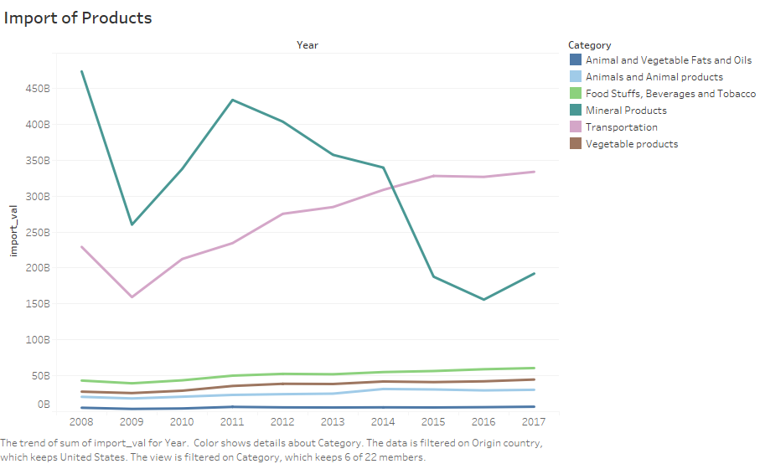

1. The below graph shows that the imports of fruits is increasing

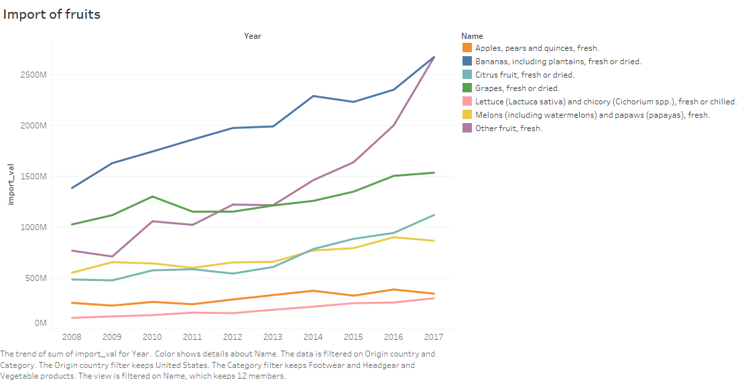

1. The below graphs are plotted to check the import export trend of the few important product categories for the top trading partners

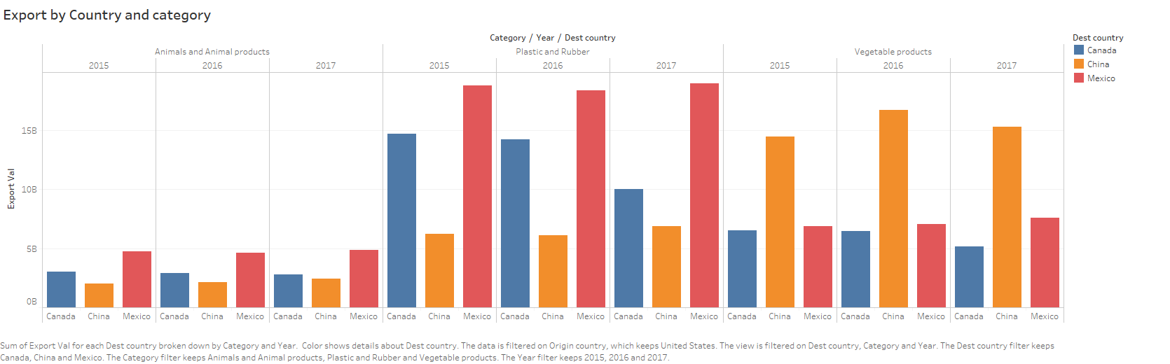

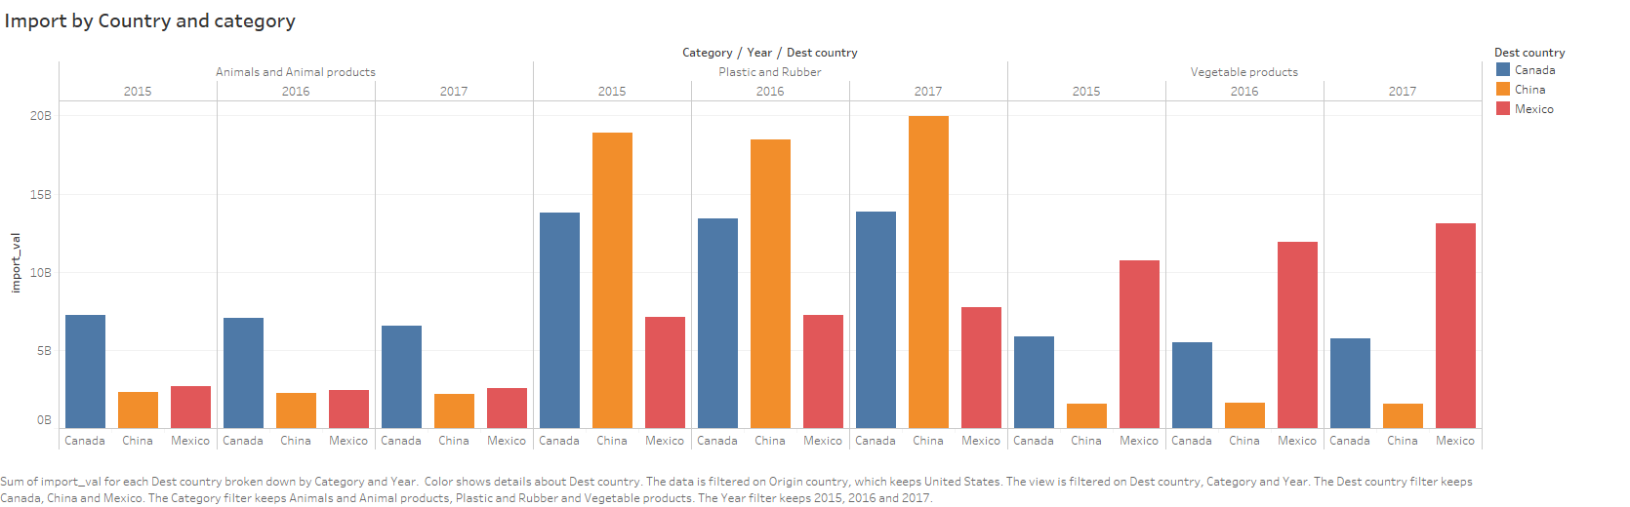

1. The maps are plotted to see if region has any role to play in the imports and exports of the products

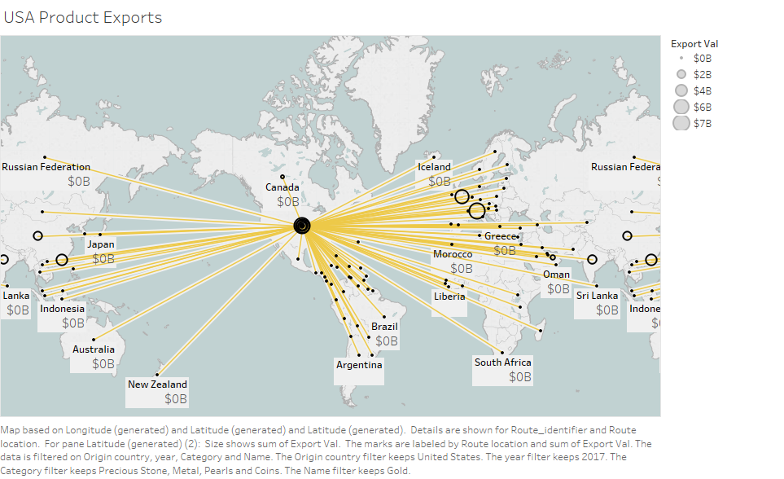

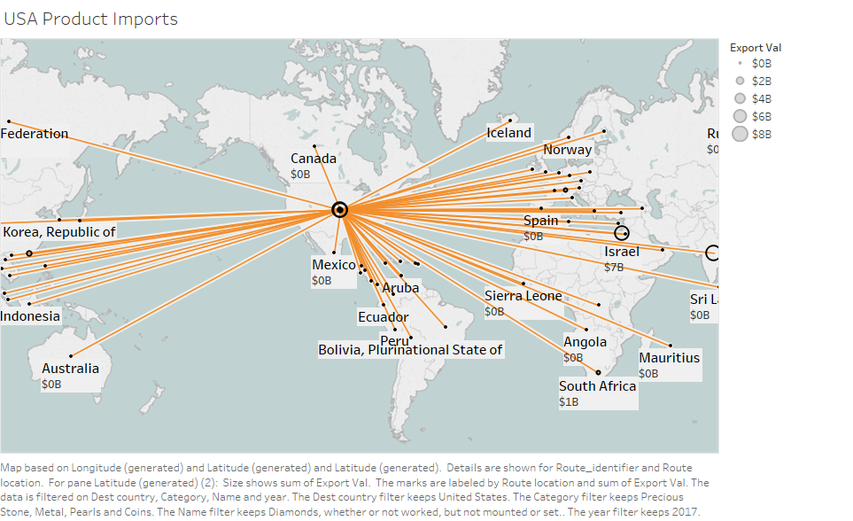

1. The below plots are created to see the top countries where USA exports the most, the trend of exports to these countries, what are the most exported products to these countries and the trend of export of these products.

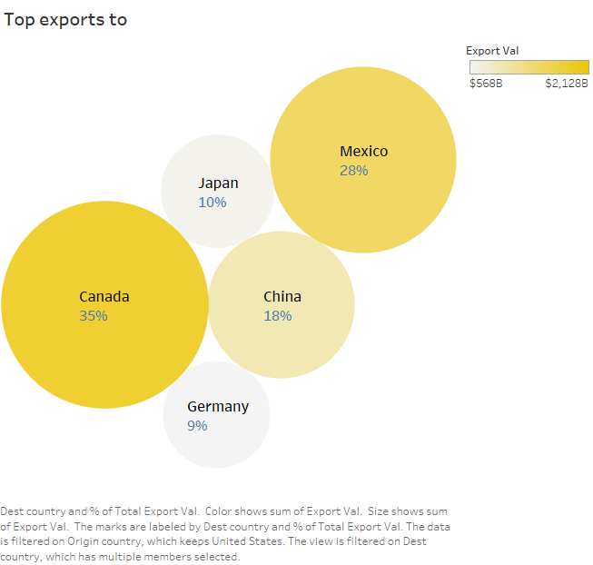

Close to 65% of the total exports go to Canada and Mexico because of the multilateral trade agreements like NAFTA

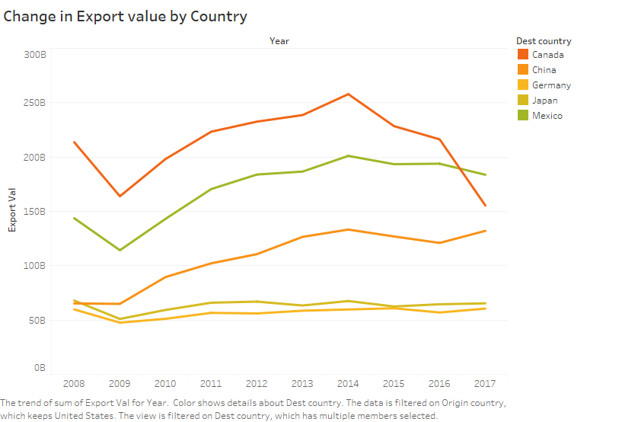

Exports to Canada are seen to be going down after 2014. China had to impact of recession on the overall exports from USA while for others it decreased.

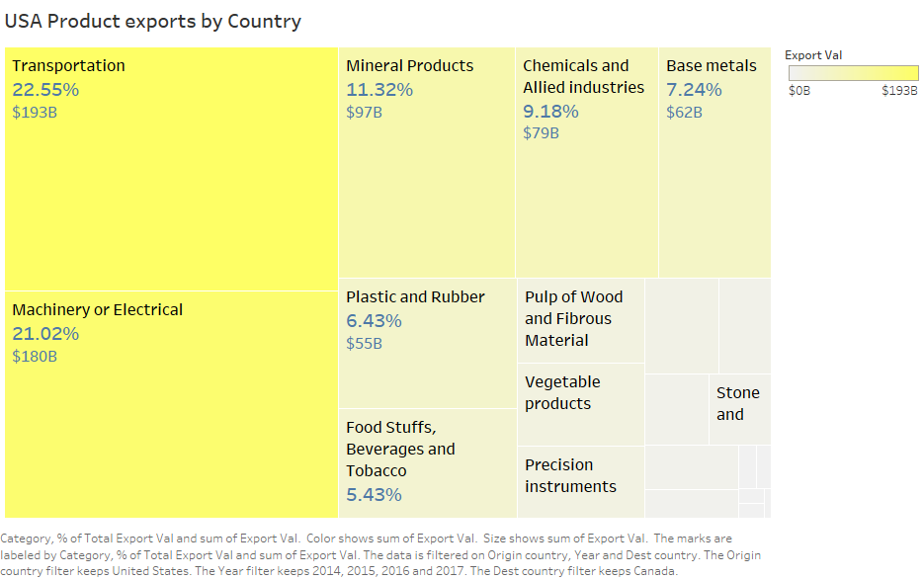



1. The below plots are created to see the top countries from where USA imports the most, the trend of imports from these countries, what are the most imported products from these countries and the trend of import of these products.

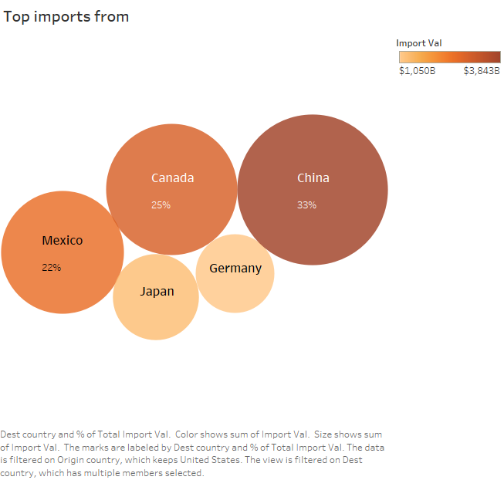

USA imports more from China than from Canada and Mexico

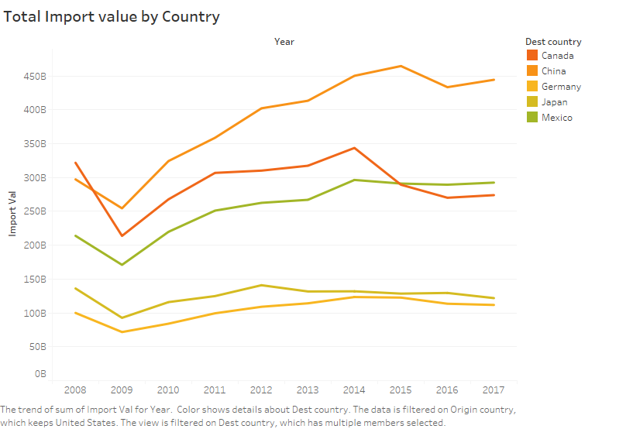

Before 2009, more USA imported more from Canada than from China. After 2009, imports from China increased as the cheaper products helped to maintain a low cost of living post-recession.

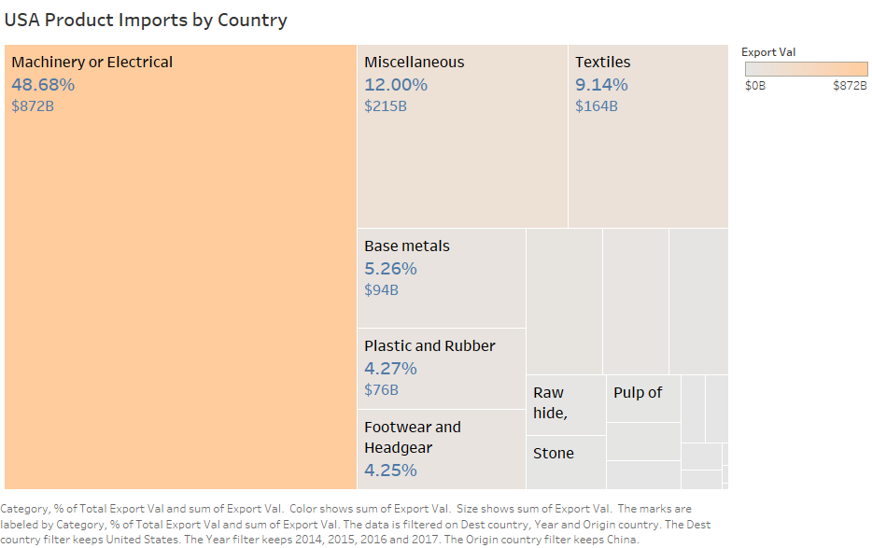

Around 50% of the total imports from China are in machineries and electricals

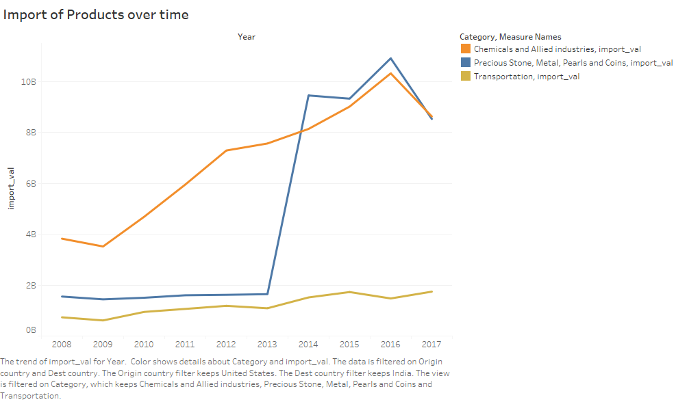

There has been a sudden surge in the imports of precious stones from India in 2014 as around this time India had established center for diamond and colored gemstone processing and trading. Also, there has been a humongous increase in the imports of chemicals from India.